NOMBRE DE LA MATERIA

Fundamento de Redes

NOMBRE DEL DOCENTE

Rafael Preciado Gutiérrez

NOMBRE DEL TRABAJO

Examen

NOMBRE DEL ALUMNO

Alejandro Guevara de Luna

UNIDAD

2

FECHA Y LUGAR

28 de octubre del 2022

**Instrucción 1:** Cablea correctamente los siguientes dispositivos:

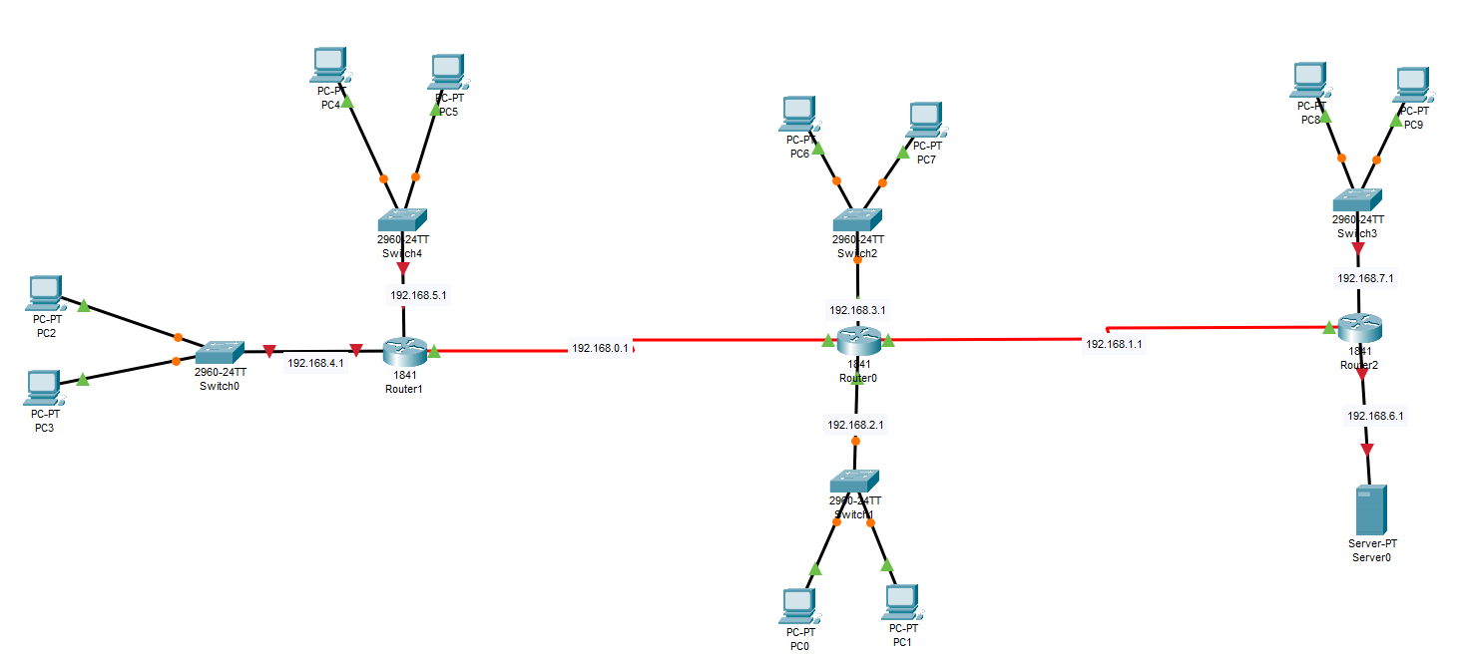

**Instrucción 2:** Configura la siguiente red, adjuntar tabla de ip’s.

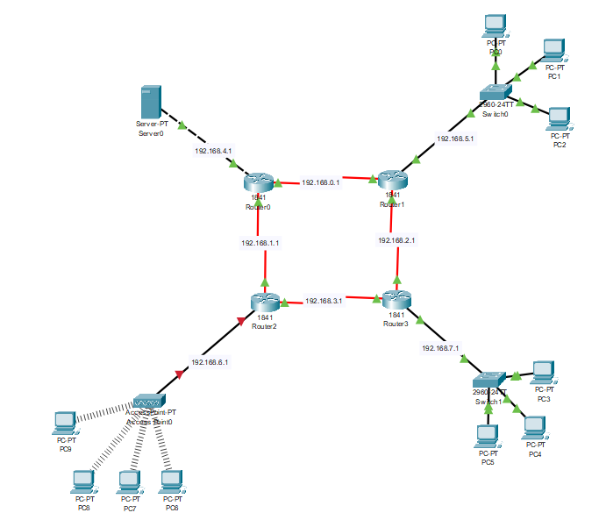

Configuración IP’s:

|  |  |  |  |  |
| --- | --- | --- | --- | --- |
| Dispositivo | Puerto | IPv4 | Mascara | Gateway |
| Router 1 | S 0/0 | 192.168.0.1 | 255.255.255.0 | NA |
| S 0/1 | 192.168.1.1 | 255.255.255.0 | NA |
| Fa 0/0 | 192.168.4.1 | 255.255.255.0 | NA |
| Router 2 | S 0/0 | 192.168.0.2 | 255.255.255.0 | NA |
| S 0/1 | 192.168.2.1 | 255.255.255.0 | NA |
| Fa 0/0 | 192.168.5.1 | 255.255.255.0 | NA |
| Router 3 | S 0/0 | 192.168.1.2 | 255.255.255.0 | NA |
| S 0/1 | 192.168.3.1 | 255.255.255.0 | NA |
| Fa 0/0 | 192.168.6.1 | 255.255.255.0 | NA |
| Router 4 | S 0/0 | 192.168.2.2 | 255.255.255.0 | NA |
| S 0/1 | 192.168.3.2 | 255.255.255.0 | NA |
| Fa 0/0 | 192.168.7.1 | 255.255.255.0 | NA |
| Server 1 | Fa 0/0 | 192.168.4.2 | 255.255.255.0 | 192.168.4.1 |
| PC0 | Fa 0/0 | 192.168.5.2 | 255.255.255.0 | 192.168.5.1 |
| PC1 | Fa 0/0 | 192.168.5.3 | 255.255.255.0 | 192.168.5.1 |
| PC2 | Fa 0/0 | 192.168.5.4 | 255.255.255.0 | 192.168.5.1 |
| PC3 | Fa 0/0 | 192.168.6.2 | 255.255.255.0 | 192.168.6.1 |
| PC4 | Fa 0/0 | 192.168.6.3 | 255.255.255.0 | 192.168.6.1 |
| PC5 | Fa 0/0 | 192.168.6.4 | 255.255.255.0 | 192.168.6.1 |
| PC6 | Wireless | 169.254.68.172 | 255.255.255.0 | NA |
| PC7 | Wireless | 169.254.0.50 | 255.255.255.0 | NA |
| PC8 | Wireless | 169.254.28.233 | 255.255.255.0 | NA |
| PC9 | Wireless | 169.254.189.67 | 255.255.255.0 | NA |